The instructions for constructing the Colonial Hills Civic Association Easter Egg Hunt course have been passed down orally from volunteer to volunteer and/or inferred by a prior year’s observation of the completed artifact. I have documented these instructions herewith to try to improve the efficiency of completing this task.

The diagram on page 4 shows the layout I remembered from my observation of the completed course during the three previous years I assisted the Event Chair in constructing it, and reflects agreement with the current year’s Event Chair that this layout is appropriate.

The course has seven lanes, each approximately 9 feet wide and 90 feet long. 5-foot garden stakes are pounded into the ground at the specified points. The stakes are connected with pink plastic flagging tape to create the lanes.

Supplies Needed:

Garden Stakes: As shown in the course diagram, 24 stakes need to be pounded. The 5-ft garden stakes are sold in bundles of 6. Therefore the required number of bundles is 4 plus one extra bundle for contingencies (badly bent stakes, stakes possibly being broken in pounding, etc.) = 5 bundles.

Pink (“Glow Pink”) Plastic Flagging Tape: As shown in the diagram, the dimensions of the course are approximately 63 feet wide by 90 feet long. Thus, there are eight 90-feet lengths to be strung with tape, and two 63-feet widths. 8 times 90 feet = 720 feet, plus 2 times 63 feet = 126 feet, for a total stretch of approximately 846 feet. The flagging tape is sold in rolls of 1 inch x 200 feet. 846 feet divided by 200 ft/roll = 4.23 rolls. Therefore, the number of rolls needed is 4.23 rounded to the next integer = 5, plus 1 extra roll for contingencies (liberal wrapping around stakes, tape breaking and the broken ends needing to be tied together, etc.) = 6 rolls.

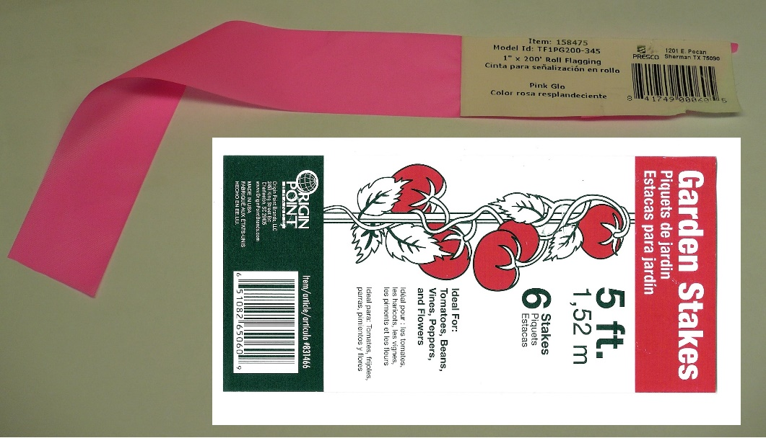

Tools Needed:

Regular Hammer (to pound the stakes into position)
Small (Short Handle) Sledge Hammer (to complete pounding the stakes deep enough not to be knocked over)
Scissors (to cut the plastic bindings around the bundles of garden stakes)
Gloves (to hold the stakes while pounding to prevent getting splinters)

Course Construction Instructions:

1) It is suggested that at least one adult volunteer, plus one assistant (who can be a youth volunteer) begin construction around 8:00 AM on Event Day. This start time should be as directed by the Event Chair, in that access to the Selby Park Shelter House may be needed to obtain the garden stakes and flagging tape (purchasing supplies is the responsibility of the Event Chair), and communication with the Event Chair would be needed in case the event might need to be postponed to the next Saturday due to inclement weather.

An 8:00 AM start time should permit course completion by around 9:00 AM, such that other event volunteers may distribute the eggs in the lanes well before the start of the event at 10:00 AM sharp.

2) Pound the first stake in the northwest corner of the course, about 9 feet away from the basketball hoop (and a few feet away from the newly-planted tree), so as to leave enough room for residents to gather on the grass between the blacktop and the western starting line of the course (line A-A in the diagram), and so that tree(s) are well away from the course.

3) Although you could use a tape measure, I recommend you just pace off three one-yard paces (approximately 9 feet) “due south” from the first stake, and pound the second stake at the end of your third pace. After this second stake has been placed, do a “sight check” with reference points located on the homes (or their trees) directly in line with the two stakes, one home to the north and one to the south, to determine where your north-south line will be for the western starting line A-A for the course. Based on this north-south determination, adjust the placement of the second stake as necessary, so that it is along this line. Then, pound each of the remaining 6 stakes in this A-A line, at 3 pace intervals, to complete the starting line.

4) The next stake to be placed is the northernmost stake in the middle of the course, shown as the northernmost point B in the diagram. Thus, start at the northwest point A in the diagram, and pace off one-half of the length of the course heading “due east,” that is 15 paces (45 feet), and pound the stake at this point B. Using a sighting procedure similar to the above, find reference points to the west and to the east (on the homes or playground), and then visualize if you have pounded this stake such that the line A-B is at a right angle (perpendicular) to line A-A. According to this visualization, adjust where you placed stake B accordingly.

5) The next stake to be placed is the one which is 3-paces south of the first point B. The sighting procedure is the same as that used to align the points on line A-A. Thus, after this second stake on the B-B line has been driven, make sure it is in alignment with north-south reference points, and adjust the second stake accordingly. Then, with two stakes on line B-B having been placed, again sight check both of these B-B points with their respective two points on A-A, and adjust the two stakes on B-B accordingly, such that the two A-B lines are perpendicular to line A-A.

6) After you have made these adjustments with the first two stakes on line B-B, the rest of the stake placement should be relatively easy, as follows:

a. Pound the remaining six stakes to make the line B-B.

b. Then, starting with the northernmost stake at the far end of the course, at point C, place it to be in alignment with line A-B, to complete the first line A-B-C. Place the next stake due south of this stake, in line with determined north-south reference points. Then pound the last six stakes in line with both the C-C line and their respective A-B lines.

Note: I found that it is virtually impossible to perform a visual stake alignment by first pounding stakes at the far end of the course, that is, at points C (before I placed the stakes in the B-B line). This distance is just too far from points A, and I would think the only way one could set out the points on line C-C before those on line B-B would be by using a surveying laser or other measuring equipment, which is certainly beyond the scope of this task! (“It’s just an Easter Egg Course!”)

7) String the pink flagging tape around the stakes (to tie the tape to the stakes) and between the stakes to form the seven lanes and the two starting lines (one at the west end of the course and one at the east end of the course).

8) Tape the Age-Group signs (“0-2,” “3-4,” etc.) to the flagging tape, in the middle of each lane, at both starting lines. These signs are printed on 8.5 by 11 inch sheets, and are supplied by the Event Chair.

Course Diagram:
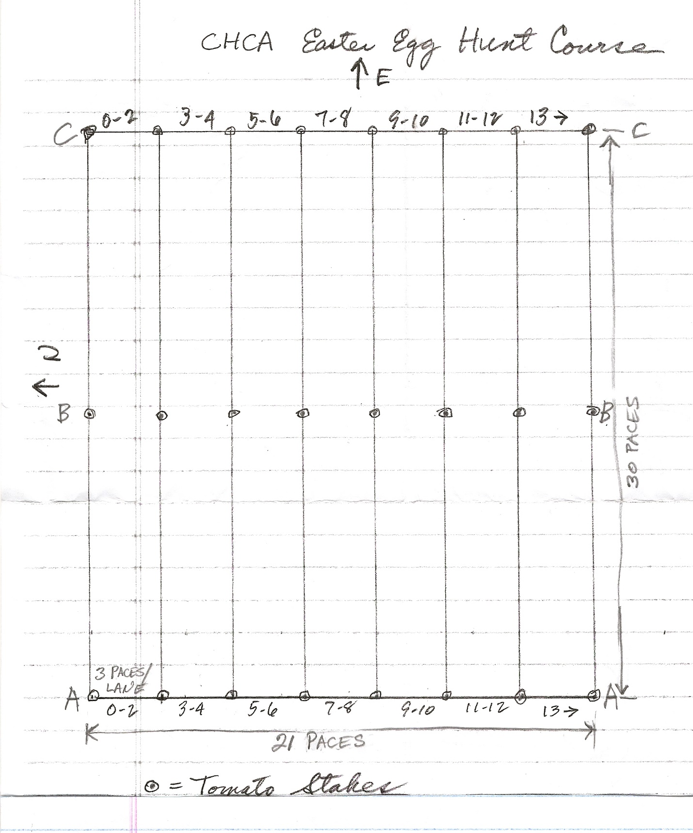

*** End of Instructions ***

